Denaby WWTP
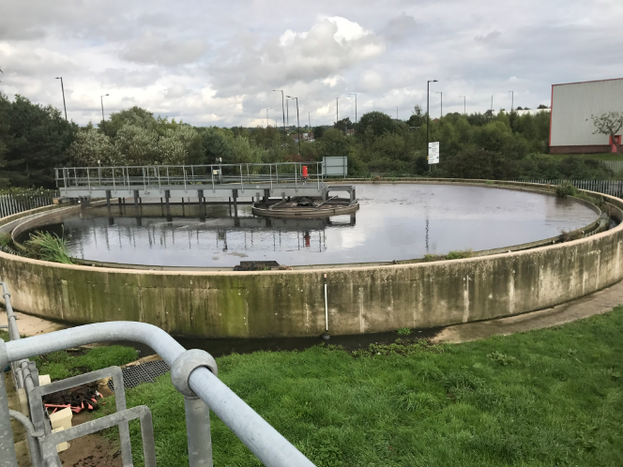
Yorkshire Water’s 35,000 PE Denaby WWTP was built in 2008 and combined flows from Denaby, (population 6,500). Burcoft (population 11,400) and Mexborough (population 17,600). The treatment plant includes primary settlement, an anoxic tank, four activated sludge lanes and two final settling tanks.

Since it was built the plant has suffered from microthrix growth and operation and performance issues. In 2017 Aquability OPS Ltd was engaged by Yorkshire Water to determine the cause of the operational issues and identify and implement the solution. The changes made by Aquability resulted in the plant achieving robust and reliable environmental performance throughout the whole year.

The Existing Plant

The Denaby WWTP treats a flow to full treatment of up to 215l/s and has a final effluent consent requirements of 25mg/l BOD (or 70% removal), 125 mg/l COD (or 75% removal) and 9 mg/l ammonia on a 95%ile spot sample basis, which is discharged to the River Don.

The activated sludge plant frequently suffered from high final effluent ammonia and solids concentrations, poor settleability and microthrix growth for around six months of the year.

Developing the Solution

In 2017, Aquability performed a detailed review of the plant and identified several causes of the poor performance including high intermittent flows to the plant from the fixed speed outlying pumping stations which also affected RAS control and DO control, MLSS was retained in the FST’s resulting in a low F/M in the aeration lanes. Conditions were being created that promoted the growth of microthrix.

Aquability provided the following services:

- Troubleshooting
- Control modifications to RAS control
- Process optimisation including control loop tuning and setpoint changes

Following the changes the plant performance immediately improved, the microthrix gradually disappeared and the plant has remained in compliance, the microthrix has not returned.

A Successful Outcome

The modifications have had a significant effect on plant performance and process reliability.

Since the changes were carried out the plant consistently achieves final effluent ammonia’s of <0.5 mg/l. The process is now very robust, maintaining compliance throughout the year.

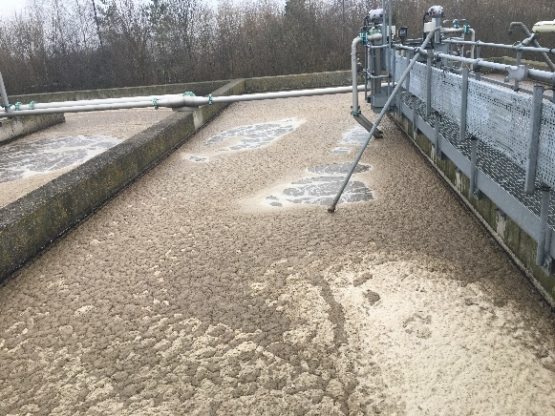
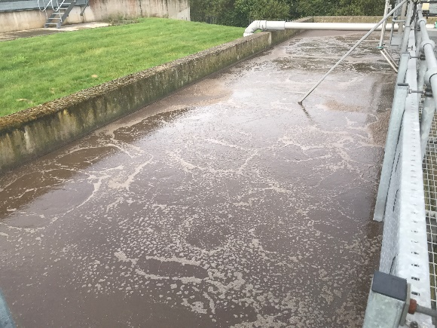
After mods: Microthrix gone
Before : excessive Microthrix present

