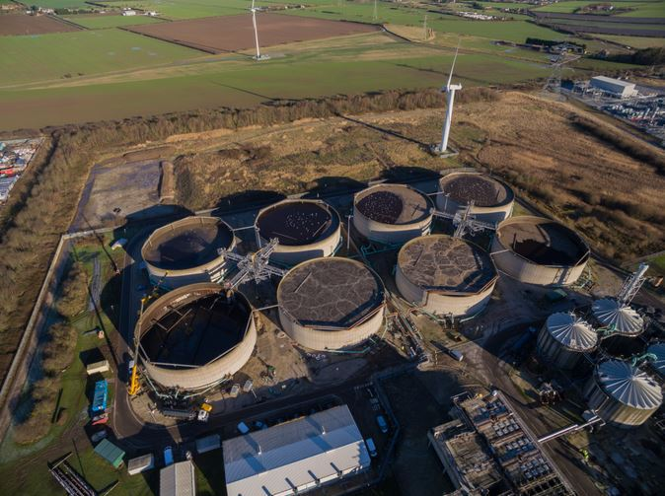
Saltend WWTP
The Saltend WWTP was built in 2001 and serves a population equivalent of over one million, with more than 50% of the incoming load from trade discharges. The plant has had a history of environmental under-performance and odour generation.

Aquability OPS Ltd helped Yorkshire Water to determine the root cause of the poor performance and develop the solution to overcome the issues, resulting in its best ever environmental performance and a 20% reduction in total power consumption.

The Existing Plant
The Saltend works treats a flow to full treatment of up to 2000l/s utilising small footprint technology, including 4 No lamella primary settlers and 8 No Sequencing Batch Reactors (SBR’s). The final effluent consent requirements are 25mg/l BOD (or 70% removal) and 125 mg/l COD (or 75% removal), which is discharged to the River Humber.

The Problem
The plant struggled to achieve effluent compliance particularly in the peak season and generated excessive odour. An odour survey identified that 54% of the odour generated was from the SBR’s and 42% from the inlet pumping station.

Developing the Solution
In 2015, Aquability performed a detailed review of the lamella’s and SBR’s and identified that the main issues were as a result of poor lamella performance, overloading of the SBR’s, major issues with all aspects of the SBR control system and the inefficient jet aeration system that was unable to satisfy the oxygen requirements of the wastewater.

Aquability OPS Ltd was instrumental in developing the successful solution for the Saltend WWTP that was implemented from September 2015 to May 2016, and provided the following services :

- Revised intermediate pumping station, lamella and SBR control philosophies
- Jar testing and sampling and analysis
- Lamella chemical dosing and sludge removal process design
- SBR fine bubble aeration system process design
- Lamella and SBR Operating plans
- Commissioning
- Process optimisation
- Troubleshooting
- Operator Training
- O&M manuals

In November 2015, Yorkshire Water contracted directly with Aquability OPS Ltd, so that the SBR control philosophy changes could be started immediately before the capital works were procured. Significant odour reduction was achieved by 1st January 2016.

A Successful Outcome
The upgrades have significantly improved plant performance, odour generation and power consumption.

Since completion of the upgrades, the plant has achieved an average COD of 82 mg/l and 85 % COD removal with a vast improvement in sludge settleability. The process is now very robust, maintaining compliance even when operating on only six of the eight basins with no odour generation.

The increased efficiency of the FBDA and revised control system have reduced air flow requirements by more than 50% with a 20% reduction in overall site power consumption.

Due to the success of the SBR control modifications and upgrades, Yorkshire Water are looking at performing similar upgrades at their other SBR plants with Aquability OPS Ltd.

