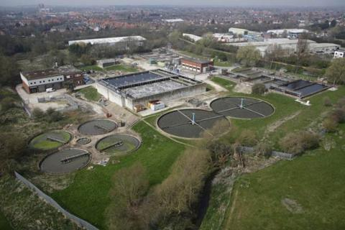
Beverley WWTP

Yorkshire Water’s 34,000 PE Beverley WWTP was upgraded in 1999 to include a new nitrifying tertiary treatment process which consisted of two rectangular CASS SBR basins.

Over the last few years the plant has struggled to reliably achieve the required plant performance. In 2016 Aquability OPS Ltd was engaged by Yorkshire Water to determine the root cause of the poor performance and to implement a solution to improve operation and performance. The changes made by Aquability resulted in the plant achieving its best ever environmental performance.

The Existing Plant

The Beverley WWTP treats a flow to full treatment of up to 291l/s utilising primary tanks, trickling filters, humus tanks and CASS SBR’s. The final effluent consent requirements are 25mg/l BOD (or 70% removal), 125 mg/l COD (or 75% removal) and 10mg/l ammonia on a 95%ile spot sample basis, which is discharged to the River Hull.

The CASS SBR plant frequently suffered from loss of nitrification and poor settleability. Talc was dosed on a regular basis to try and improve settleability and prevent loss of solids in the final effluent.

Developing the Solution

In 2016, Aquability performed a detailed review of the plant and identified that the main causes of the poor performance were overloading to the SBR’s, poor primary tank performance as a result of unreliable sludge removal equipment, incorrect SBR settings, and issues with the SBR control system.

Aquability provided the following services:

- Troubleshooting
- Revised SBR control philosophy
- Jar testing and sampling and analysis
- Primary tank chemical dosing trials
- Commissioning
- Process optimisation

Following the changes to the SBR settings and control in March 2016 the plant performance immediately improved and the plant has remained in compliance ever since. Chemical dosing is not required following the optimisation of the SBR’s.

A Successful Outcome
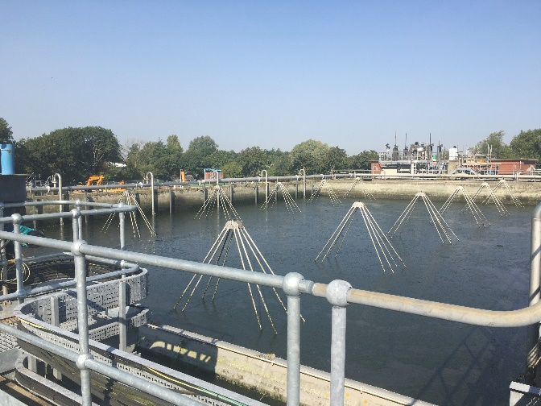
The SBR modifications have had a significant effect on plant performance and process reliability.

Since the changes were carried out the plant achieves average final effluent ammonia’s of ~0.4 mg/l and 95%ile ammonia’s of < 1.5 mg/l with a significant improvement in settleability. The process is now very robust, maintaining compliance even when the SBR plant receives loads that are significantly higher than design.

Due to the success of the SBR control modifications, Yorkshire Water have engaged Aquability to performing similar optimisation at their other SBR plants.

